Bayport Marina Association
Board of Directors Meeting Minutes
May 19, 2022

Member | Present | Remote | Absent
Curt Gray (Commodore) | x
Rachael Harvey (Vice Commodore) | x
Meredith Pederson (Treasurer) | x
John Gagich (Secretary) | x
Bob Reilly (Chair) |  |  | x
Jason Fabio (Chair) | x
William Given (Chair) | x
Bryan Wilkinson (Chair) | x
Erik Westgard (Chair) | x
BMA Staff/Guests | Present | Remote | Absent
Kori Derrick-Cisewski (General Manager) | x
Eric Pederson (Ramp Access Improvement | x

Business Meeting

- Call to Order/Opening Comments/Check-in
- The BMA Board Meeting was called to order at 6:35 pm by the Commodore, Curt Gray. It was confirmed that a quorum was in attendance for approval of business items.
- Guest appearance – King Boreas and the Prime Minister of the Winter Carnival made an appearance to award Kori and Curt with the certificate of Knighthood. Also in attendance is Eric Pederson.
- Opening comments: Will start with Check-in then Consent Agenda. Meeting started with a moment of silence for loss of Steve Paquette former Board Member.
- Check-In - A round table discussion and check-in conversation of what is on everyone’s mind was conducted. No specific discussion recorded for this meeting.

- Consent Agenda – discussion/approval: April minutes, April financials and GM Report
- Rachael – made a motion to approve April Minutes and Financials, Meredith seconded – No discussion, Motion approved and carried.

- GM Report – Kori – met with the architect that created plans for the clubhouse and looked at ADA compliance stalls for unisex bathroom access and to look at some incremental improvements in meeting area. Kori asking the board to review the plans and to move forward with bids with contractors. $70,000 to $80,000 rough estimate was identified by the architect initially.
  - Motion was made by Jason to approve Kori to move forward with seeking out bids and to talk with architect and city to understand what compliance requirements. Rachael seconded - No discussion, Motion approved and carried.

- Annual Membership meeting: Set for Wednesday, June 15th. Kori identified meeting room layout as well as communications online. Focus on tonight’s meeting, for stewardship circle leaders to get comfortable for presenting outcomes of work for each circle. Agenda for membership meeting was reviewed and draft slides was presented by Kori and Curt.
  - Capital Investment Stewardship Circle Presentation Reviews:
    - Service Expansion (Rachael)
    - Dredging (Kori)
    - Landscaping (Meredith)
    - Dock Ramp/ADA Access (Kori for Eric Pederson)
    - Clubhouse Remodel (Jason)

- Other Business
  - Board Candidate Search – discussion was had for BOD candidate search, two candidates are required for the next board term. Katy Baune has accepted. Another candidate Don Grimm is interested, and Kori will circle back. Scott Reneke is also another prospective candidate. The cutoff for nominations is May 26th. Curt and Bob are completing their terms on the board.
  - Staff succession planning – Kori and Curt worked together on the process and planning for a formal plan. Business process includes an interview process with each employee to determine future plans for retiring. This information will be used for planning purposes for position replacement. Additional conversations with employees also brought other desires to move into alternative positions in the marina.
  - Erik – Inquired Railroad property easement – looked at the deed on property. There is no easement for the people who own the beach property located by our boat ramp.
  - BMA Annual Commodore’s Party – planned for June 17th. 5:30 pm, cocktails

- Executive Session (if needed) – Not needed.
- Adjournment – 8:30 PM. Motion to adjourn, Rachael, seconded by Bill

Addendum 1

General Manager Report – May 2022 Board Meeting
Report Published: 5/12/22
BMA Staff
- Even though we have been incredibly busy, we seem to be getting through everything efficiently and with little challenges. However, because of shifting launch three days, our Tuesday launch day has been come Friday meaning the staff is pretty tired by the end of the week, so I have gotten feedback about that.
- I feel very fortunate that the team feels very united right now, and the statement “All Hands-On Deck” could not be truer. Additionally, there is no one who uses the phrase, “that’s not my job” when asked to anything around here. Again, I can’t speak highly enough of the skills and work ethic of the staff.

BMA Financials
Profit and Loss Budget vs Actual – March 2022:
- Total Income: $1,174,665; up $37,650 vs budget; up $86,091 vs last year
- Total Expense: $1,082,785; down $103,691 vs budget, up $192,846 vs last year
- Net Ordinary Income: $91,880; up $141,340 vs budget; down $106,754 vs last year o Balance of CI Budget remaining for FY: $42,225

Balance Sheet as of March 31, 2022:
- Total assets: $5,840,940; up $18,107 vs last year o Cash: $1,015,061
- Total liabilities: $273,216; down $80,880 vs last year o BMRP loan balance is $208,368

AR Aging Summary as of May 12, 2022:
- Total A/R Balance: $120,974
- Over 30 days A/R balance: $8,887
- Of the $8,887, $3,327 of it is Group 41

Operations
- By the end of today we will have 131 boats in the water. Most days we get in at least 8 boats, but we had three days of either getting 11 boats in or 11 boats moved (in and out of the shop for work).
- The last two off-season boats are in the shop right now, so our updated schedule has been right on track.
- The new fuel pumps were installed on April 18 and the new system makes tracking the fuel sales much easier. We will be getting our BMA logo installed on them for branding.
- The city has not approved our permit for the tree cutting on the banks because of our Conditional Use Permit (CUP) requiring screening from the St. Croix River. They are meeting with the DNR to discuss how to move forward with the project. The CUP requires us to replace trees one for one if they are being cut down if they are over 6” in diameter if they are not dead.

Thought Work/Decisions
- At the last board meeting we discussed the possible option of converting the storage area in front of the men’s bathroom into an ADA compliant bathroom. See below for the proposed Blueprint. The contractor from Ispiri, that met with me, and the architect is ballparking the job at $70 - $80,000. I would like to get the boards feelings if this is worth pursuing as a short-term solution for the Clubhouse remodel. If there is interest, I would move forward with getting multiple bids as well as exploring the costs of updating the clubhouse conference room flooring and making some updates in the kitchen.

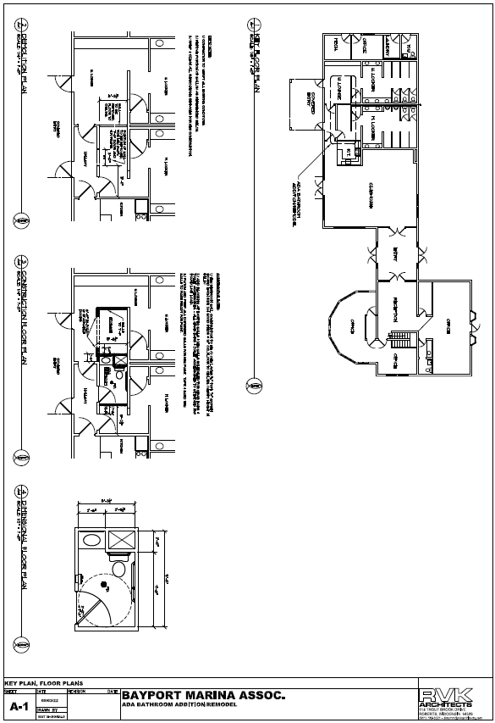

Same Image, just larger

